Impact Of Recruitment Sources And Selection Panel Levels On Candidate Selection Outcomes

BY
RUPESH KUMAR
(Admission No. 23MB0052)



THESIS
SUBMITTED TO
Prof. Sabnam Basu
Department of Management Studies and Industrial Engineering
INDIAN INSTITUTE OF TECHNOLOGY
(INDIAN SCHOOL OF MINES), DHANBAD

For the award of the degree of
MASTER OF BUSINESS ADMINISTRATION
November, 2024

DEPARTMENT OF MANAGEMENT STUDIES AND INDUSTRIAL ENGINEERING
(Accredited by AICTE and UGC)

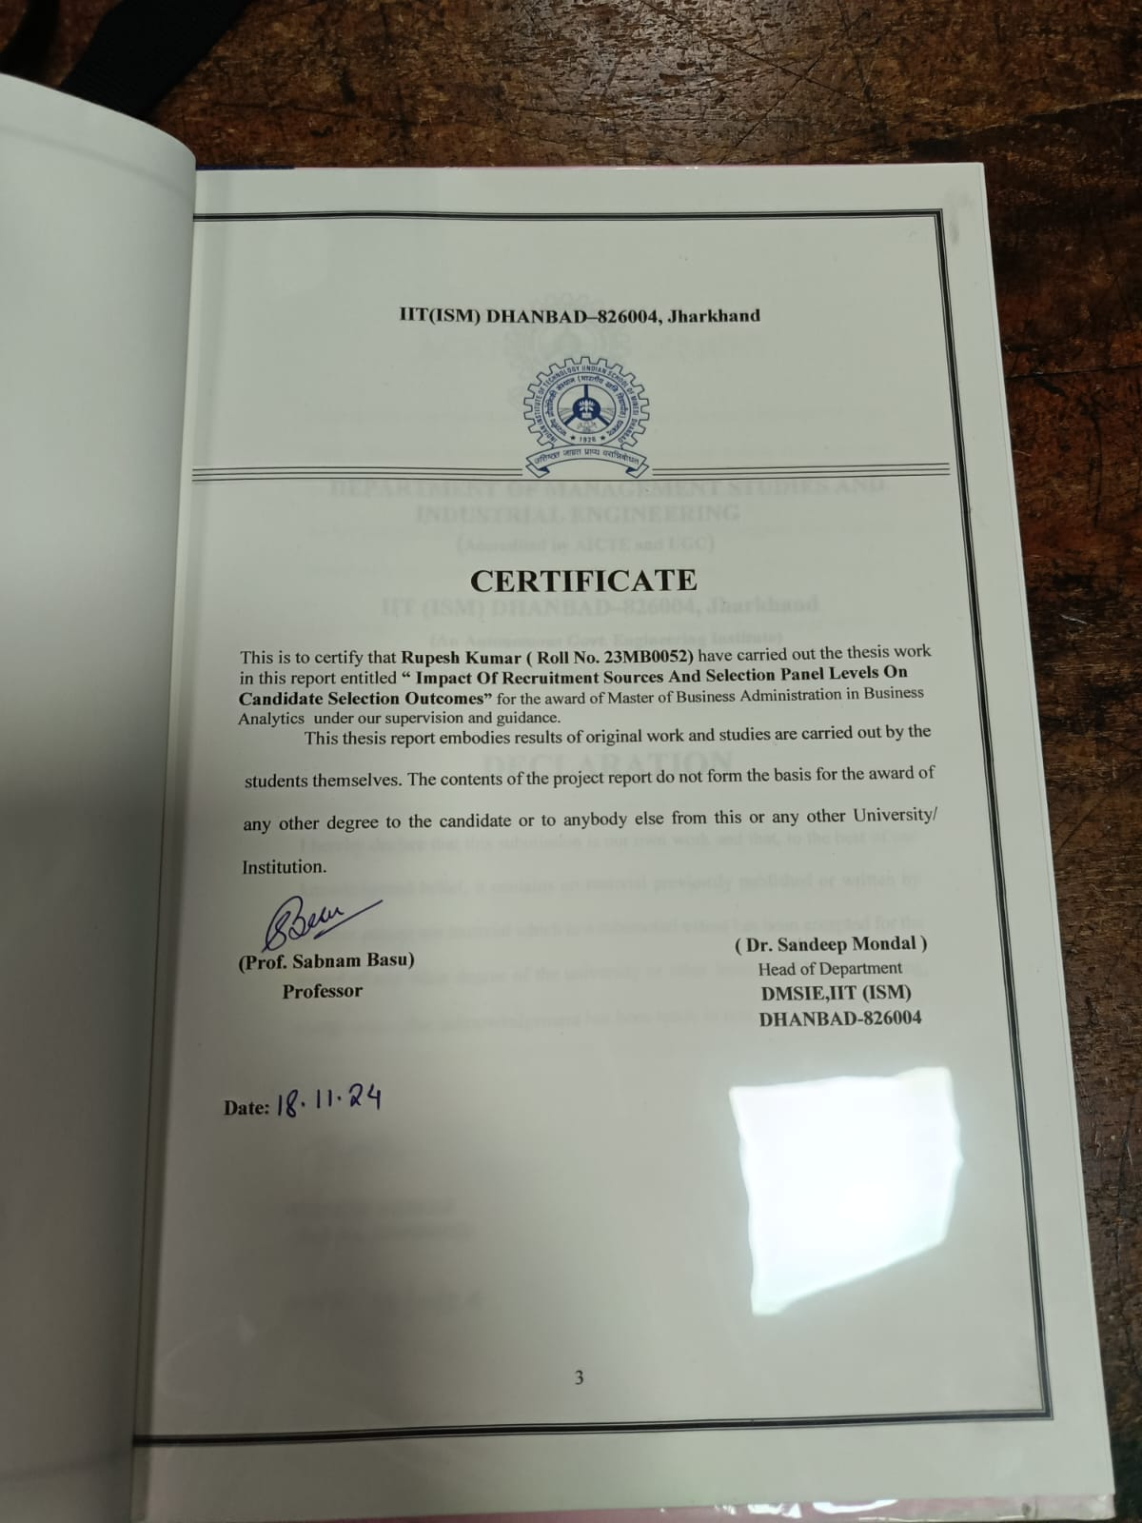

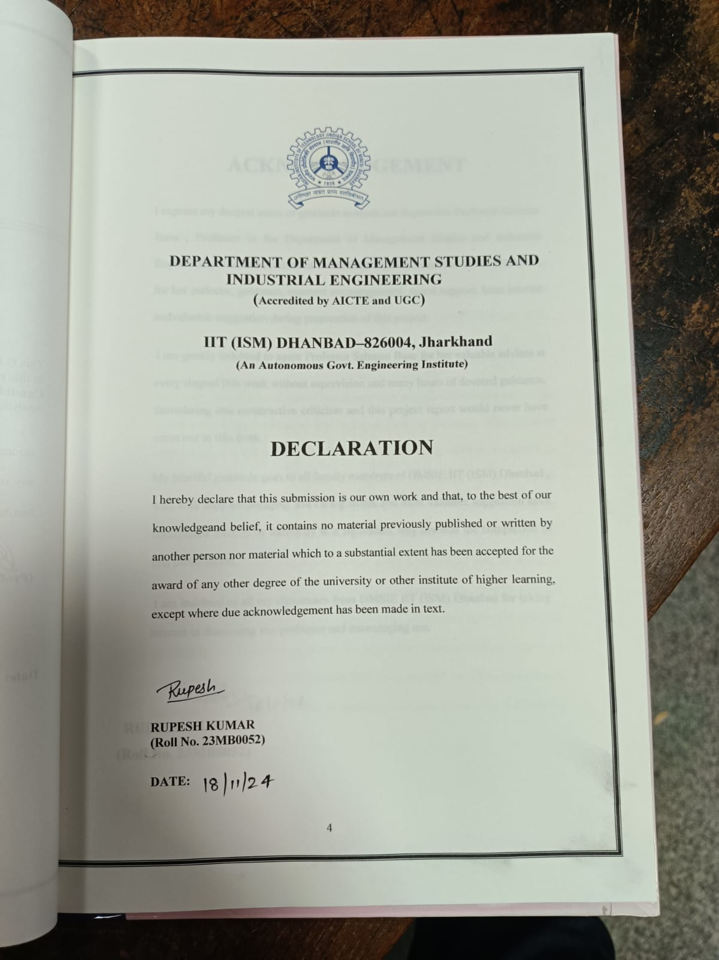



ABSTRACT

The study investigates the impact of recruitment sources and selection panel levels on candidate selection outcomes. Taking data from XYZ, statistical calculation such as logistic regression reveals significant relationships between recruitment source and selection rates. The findings align with prior research that show the importance of recruitment sources in influencing post hire success (Williams et al., 2003).

This study explores the impact of recruitment sources and selection panel levels on candidate selection outcomes. The research aims to determine how different recruitment channels influence the chance candidates being selected or rejected, as well as how the level of the selection panel affect this relationship. Work on the Secondary data were detailed records of recruitment sources and selection outcomes, categorized by panel levels, for a comperehensive analysis. Statistical tests result reveal that recruitment source plays a significant role in selection outcomes, with certain channels yielding higher selection rates. Additionally, the level of the selection panel L1 to L2 significantly influencing candidate selection probability. The outcomes suggested that recruitment channels and panel level are critical factors in final selection results, indicating the need for tailored recruitment strategies and panel composition to optimize candidate assessment and improve selection acuracy.

TABLE OF CONTENTS

CERTIFICATE 2
DECLARATION 3
ACKNOWLEDGEMENT 4
ABSTRACT 5
TABLE OF CONTENTS 6
CHAPTER 1 8
CHAPTER 2 12
LITERATURE REVIEW 13
2.1 Recruitment Sources and Their Impact on Selection Outcomes 13
2.2 Selection Panel Composition and Its Influence on Hiring Decisions 14
2.3 Interaction Between Recruitment Sources and Selection Panel Composition 14
Chapter 3 15
Methodology 16
3.2 Data Sources 16
3.3 Data Variables 16
3.3 Analytical Methods 16
3.4 Research Design 17

Chapter 4 17
Data Analysis and Results 17
4.1 Overview of the Dataset 18
4.2 L1 Success Rate Analysis 18
4.2 L2/Final Panel Success Rate Analysis 19
4.3 Comparative Analysis 20
CHAPTER 5 22
HYPOTHESIS TESTING 22
Findings 23
Conclusion 24
Hypothesis Decision 24
References

CHAPTER 1

1.1 INTRODUCTION

Recruitment and selection are most important to build an organization's workforce, influencing not only the quality of hires but also their long-term success and retention. The different methods used in recruitment have evolved significantly, spanning from newspaper advertisements to modern-day digital platforms,(linkedin,Naukari,Monster) employee referrals, and internal job postings. These recruitment channels directly impact the effectiveness of talent acquisition strategies (Michael A. Zottoli, 2000).Researches has shown that some sources, such as employee referrals and specialized job boards, are often more successful in attracting higher-quality candidates than traditional methods.

Several studies highlight the strong relationship between recruitment sources and post-hire outcomes, such as job performance and retention (Williams, Labig, & Stone, 2003). These outcomes are critical for organizations aiming to minimize turnover costs and maximize workforce efficiency. Similarly, Weller et al. (2020) emphasized the role of early voluntary turnover in determining the overall effectiveness of different recruitment strategies. Notably, the level at which candidates are recruited, whether through senior leadership or lower-level managers, can also influence the eventual success of the hire.

In parallel, the selection panel's composition how many levels of decision-makers are involved has been shown to affect the fairness and thoroughness of the candidate evaluation process. The involvement of multiple levels within an organization can improve the overall accuracy of decisions, but it also may introduce biaseness or delays in the hiring process Suwarto and Subyantoro (2021) illustrates how the recruitment process, combined with careful selection procedures, impacts employee performance. The effectiveness of recruitment sources and selection panel levels, therefore, forms a dynamic interaction that impacts not only immediate hiring decisions but also long-term organizational success.
1.2 Research Problem
Despite considerable research on recruitment strategies, a significant gap remains in understanding the direct relationship between recruitment sources and candidate selection outcomes, as well as the influence of selection panel composition. Existing literature suggests that different recruitment sources attract varying candidate pools, which is turn the affect of selection outcomes such as job performance and retention (Zottoli & Wanous, 2000).
However, it is not fully understood how the choice of source impacts the final decision in candidate selection. Additionally, the role of multi-level selection panels remains underexplored in existing studies, with few examining how panel composition affects fairness, decision-making, and final hiring success (Werbel & Landau, 1996). These gaps in the literature emphasize the need for further investigation into how these factors interact to influence organizational hiring practices.
1.3 Objectives:
Analyze the impact of various recruitment sources on candidate selection outcomes, investigating how different sources such as job boards, employee referrals, and internal postings influence hiring success rates.
Examine the affect of different selection panel levels on hiring decisions, assessing how the composition and number of decision-makers within the panel shape candidate evaluations.
Find which recruitment sources are associated with higher selection rates, by analyzing historical recruitment data and drawing correlations between source type and final selection outcomes.
1.4 Scope of the Thesis
The study will focus on recruitment data from XYZ . It will analyze various recruitment sources, including naukari, monster,linked in, ORC,and online job boards, employee referrals, and internal job postings. Selection outcomes will be measured by offer acceptance rates and other relevant success metrics, with particular attention to how these outcomes differ across the various sources. Additionally, the impact of selection panel levels on candidate success will be explored in relation to panel decision-making processes.
1.5 Hiring Flow Diagram
The diagram below visualizes the key stages in the hiring process .how candidates move from recruitment to final selection:
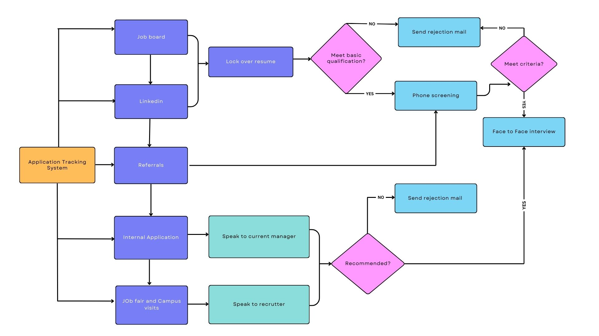
HIRING FLOW CHART

- Recruitment Sources:
  - Job Boards
  - LinkedIn
  - Referrals
  - Internal Applications
  - Job Fairs and Campus Visits
- Initial Screening:
  - Phone Screening
  - Application Tracking System (ATS) for resume filtering
  - Screening by recruiters
- Evaluation:
  - Resume Review (check for qualifications)
  - Shortlisting candidates based on criteria
  - Interview (phone or in-person)
- Final Selection:
  - Face-to-Face Interview
  - Panel Evaluation
  - Job Offer
- Post-Hire:
  - Offer Acceptance
  - Onboarding
Each stage in this hiring flow plays a critical role in shaping candidate outcomes. The data analysis in this thesis will focus on identifying which recruitment sources and stages most significantly impact the selection results, based on trends observed.

CHAPTER 2

LITERATURE REVIEW

2.1 Recruitment Sources and Their Impact on Selection Outcomes
Recruitment sources play a pivotal role in shaping the candidate pool and influencing the quality of applicants. Traditional recruitment methods, such as newspaper ads, have evolved with the rise of digital platforms like job boards, LinkedIn, and employee referrals. Research suggests that employee referrals are particularly effective at attracting candidates who are more likely to perform well and stay longer with the organization. The referred candidates tend to have a better cultural fit and higher performance, as they are often pre-screened by the referring employee Zottoli & Wanous (2000). Similarly, Some researcher found that referrals not only attract candidates who better align with company values but also contribute to reduced turnover rates Williams et al. (2003).
Job boards, on the other hand, provide access to a broader pool of candidates, often from diverse backgrounds, offering both an advantage and a challenge. Weller et al. (2020) observed that while job boards bring in diverse talent, they also increase the complexity of the screening process. The volume of applications can overwhelm recruiters, requiring more resources to evaluate candidates effectively. However, when paired with a strong application tracking system (ATS), job boards can streamline the process, enhancing the overall efficiency of recruitment.
LinkedIn has become a dominant platform in modern recruitment, particularly for sourcing passive candidates—those not actively seeking new employment but open to opportunities. Holtom et al. (2021) note that LinkedIn’s targeted approach to connecting professionals makes it an ideal source for roles requiring specific skill sets or industry experience. Moreover, Now a days we observed that LinkedIn offers a higher quality of applicants, particularly for mid-to-senior level positions, compared to job boards or job fairs.
Internal recruitment sources also have distinct advantages. Internal job postings help retain and motivate existing employees by offering career growth opportunities Williams et al. (2003). However, internal candidates may sometimes have biases in their favor, which could lead to favoritism or a lack of diversity in the hiring process (Werbel & Landau, 1996).internal candidate some times well known about the recruiter and their policy.

2.2 Selection Panel Composition and Its Influence on Hiring Decisions
The composition of the selection panel can significantly affect hiring outcomes. A key consideration is the number and type of decision-makers involved. Panels with diverse backgrounds and varying levels of authority often provide more balanced evaluations, which can result in better hiring decisions. Werbel & Landau (1996) discuss how panels involving different levels of management can prevent biases and lead to more objective decisions by incorporating diverse perspectives.
On the other hand, involving senior-level decision-makers in the panel can sometimes lead to delays in decision-making or a more rigid approach to candidate selection. Weller et al. (2020) argue that senior panels might focus on strategic alignment and leadership qualities, potentially overlooking candidates who exhibit strong potential but lack executive experience. This may lead to the exclusion of innovative candidates who could offer long-term growth potential.
The structure of the interview itself is also crucial. Structured interviews, where each candidate is asked the same questions and evaluated against the same criteria, have been shown to be more effective in predicting job performance compared to unstructured interviews. Landau (2021) emphasizes that structured interviews are less prone to interviewer biases, making them a more reliable method for selection panels.
However, research by Holtom et al. (2021) indicates that while multiple levels of decision-making in the panel increase the likelihood of selecting high-performing candidates, they can also introduce challenges such as longer hiring cycles. Multiple evaluators may take more time to reach a consensus, which can delay the recruitment process and increase costs. Therefore, the ideal panel composition often balances the need for diverse perspectives with the goal of maintaining a timely and cost-effective hiring process.

2.3 Interaction Between Recruitment Sources and Selection Panel Composition
The interaction between recruitment sources and panel composition further complicates the hiring process. For example, candidates sourced through employee referrals may be more favorably evaluated by a panel due to the perceived reliability of the source. According to Williams et al. (2003), candidates referred by current employees may be seen as more trustworthy and aligned with organizational values. This dynamic can influence how the selection panel assesses their qualifications, often leading to a higher likelihood of selection.
In contrast, candidates from job boards or job fairs, who are less familiar to the panel, might undergo more rigorous evaluations, especially if the panel consists of senior decision-makers who are unfamiliar with the recruitment source. when recruitment sources are less familiar, panels may be more cautious in their decision-making, which can lead to longer evaluation processes or the rejection of otherwise qualified candidates Suwarto & Subyantoro (2021).
Furthermore, the use of diverse selection panels may mitigate the potential biases associated with recruitment sources. when multiple evaluators from different organizational levels assess candidates, they are less likely to be swayed by biases related to the recruitment source, leading to a more balanced decision Weller et al. (2020).
The recruitment sources and selection panel composition play a significant role in shaping hiring outcomes. The choice of recruitment source influences the pool of candidates, with referrals often yielding higher-quality candidates, while broader sources like job boards and LinkedIn offer diversity and a larger candidate pool. Similarly, the composition and structure of the selection panel significantly impact the fairness and accuracy of hiring decisions. Future research should further explore the dynamic interplay between these two factors and how they collectively affect organizational hiring success.

Chapter 3

Methodology
This chapter outlines the research approach, data sources, and analytical methods used in this study to explore the impact of recruitment sources and selection panel composition on candidate selection outcomes.

3.1 Research Approach
The study follows a quantitative research approach to examine the relationships between recruitment sources, selection panel structure, and candidate success. This method is suitable for analyzing large datasets to draw statistically significant conclusions regarding the effects of various factors on selection outcomes.

3.2 Data Sources
The Secondary data for this study will be sourced from recruitment records maintained by XYZ, which include detailed information about candidates’ qualifications, interview stages, feedback, and final outcomes. Each record includes:
- Candidate Information: Name, skill, contact details, and location
- Recruitment Source: Source of application (ex., referrals, job boards, LinkedIn)
- Interview Details: Dates, times, and panels for L1 and L2 interviews
- Feedback: Evaluation from L1 and L2 panels, including final selection feedback

3.3 Data Variables
- Dependent Variable: The primary dependent variable in this study is the candidate selection outcome, which is categorized as either success (candidate selected) or failure (candidate not selected) at the final stage of the hiring process.
- Independent Variables:
Recruitment Source: This variable reflects where the candidates were sourced from, such as internal sources (e.g., internal job postings, employee referrals) or external sources (e.g., job boards, LinkedIn, campus visits, etc.)

3.3 Analytical Methods
For analyzing the impact of recruitment sources on candidate selection outcomes, I employed pivot table analysis to calculate the percentage of candidates accepted or rejected from each recruitment source. Initially, the L1 success rate (candidates who passed the first round of interviews) was calculated, followed by the L2 success rate (candidates who passed the second round). Finally, these results were compared to identify trends and differences between the two interview stages. This approach provided insights into the effectiveness of each recruitment source in contributing to successful candidate outcomes at different stages of the hiring process.

3.4 Research Design
This study investigates the relationships between recruitment sources, selection panel composition, and candidate selection outcomes within the hiring process. This design allows for the collection of data from a variety of recruitment processes, such as employee referrals, job boards, linkedin,naukari and and panel structures impact the success rates at various stages of the hiring process (e.g., L1, L2 interviews, final selection).. Previous studies have shown that recruitment sources impact post-hire success and retention (Zottoli & Wanous, 2000; Williams et al., 2003), emphasizing the importance of this aspect. Furthermore, selection panel composition can significantly influence hiring outcomes, as diverse panel levels may bring varied perspectives and biases to candidate evaluation (Werbel & Landau, 1996).

Chapter 4

Data Analysis and Results

4.1 Overview of the Dataset
Summary of the data, highlighting the distribution of candidates across different recruitment sources, interview levels (L1, L2), and final selection outcomes.
Process
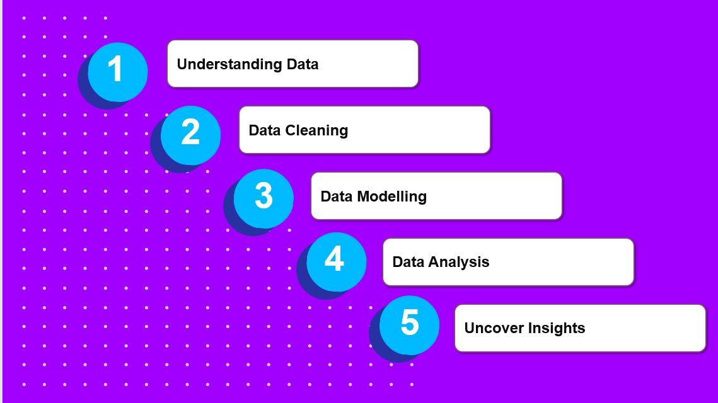

4.2 L1 Success Rate Analysis
In the given dataset, the L1 success rate analysis indicates the effectiveness of different recruitment sources:
- Vendor: The success rate is approximately 29.05% for candidates passing the L1 interview, while the rejection rate stands at 32.29%.
- Monster: This source shows no successful candidates at L1, indicating it may not be effective.
- Naukri: A significant proportion, with a success rate of 33.78% and a rejection rate of 28.21%.
- Referrals: High success with 32.77% passing L1
- LinkedIn: Low success at 0.68%, showing limited effectiveness.

- 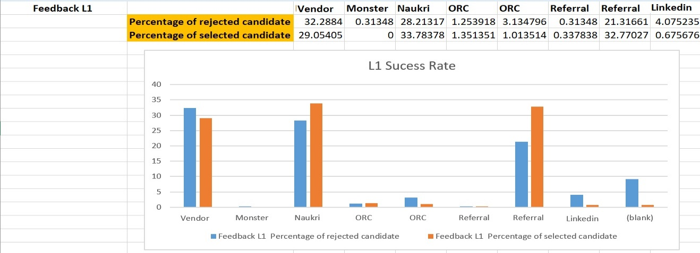

4.2 L2/Final Panel Success Rate Analysis
The L2 and final panel analysis further evaluates candidate progression:
- Vender: Shows consistent performance with a 29.13% success rate and 28.68% rejection.
- Monster: Marginal presence at 1.30% success.
- Naukri: The success rate drops slightly to 33.48%.
- Referrals: A notable decrease to 21.52%, indicating a reduction in performance from L1 to L2.
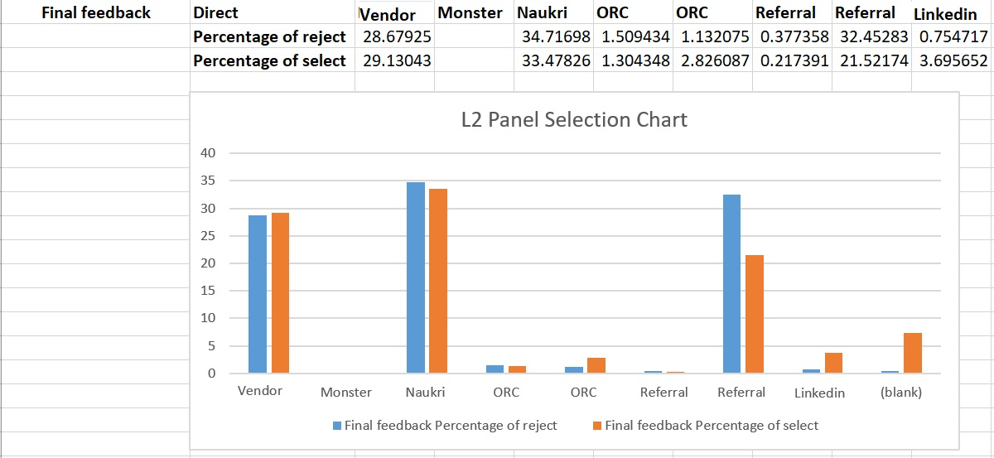

4.3 Comparative Analysis
A comparison of L1 and L2 stages:
- Vendor maintained consistent success rates across L1 and L2.
- Referrals showed strong L1 performance but a notable drop by L2, aligning with research on diminishing returns in later hiring stages.

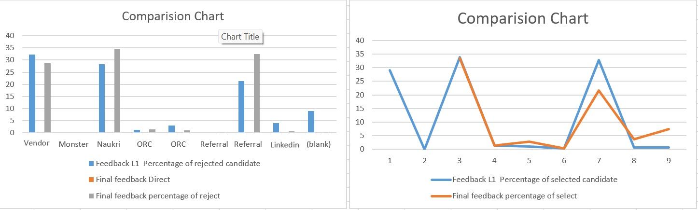

Finding and Discussion

From the above interpretation we understand that recruitment sources influences on candidate success rate at different hiring stages .for L1 interview sources like vendor and referrals shows strong performance with success rate 33.78% and 32.77% resp. monster shows no successful rates .

At the L2 Panel or final stagesv vendor maintain a constantly performance with a 29.13% success rate. Referrals decline to 21.452%.

vendor showed consistent results through L1 and L2, reinforcing its reliability in candidate selection.

Referrals, while initially strong, displayed reduced effectiveness by L2, an outcome supported by theories on source-specific advantages diminishing as candidates progress through rigorous evaluations .
Primary data Analysis
Below report is obtained by calculation on Secondary data in which different parameter like name , gender,recruitment source, no. of interview ,job satisfaction .
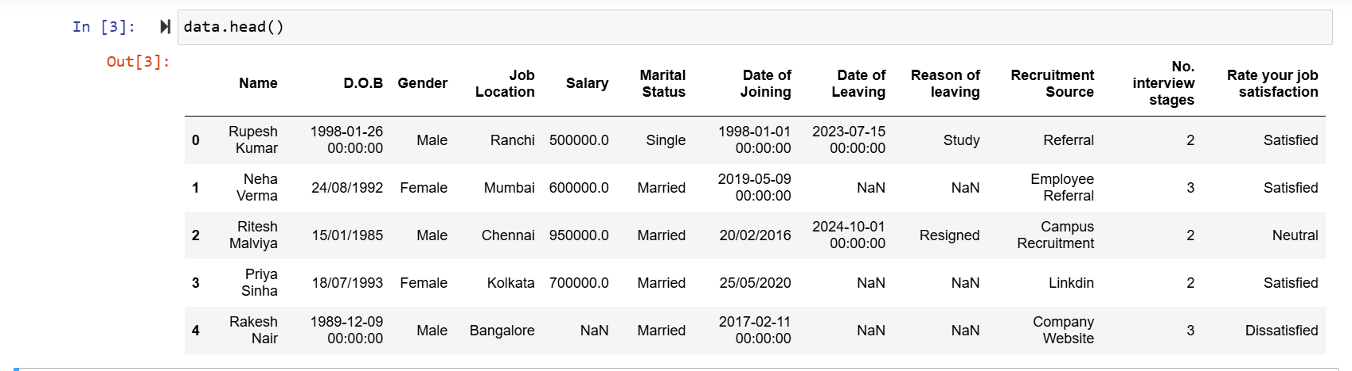
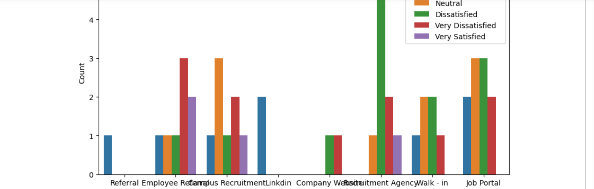

Primary data analysis gives clear patterns in the ways that various hiring sources impact employee satisfaction. When compared to candidates employed through other channels, it was found that individuals hired through employee referrals expressed higher levels of work satisfaction.This result is consistent with studies that indicate personal ties during the hiring process improve employee happiness and engagement because of the support network and prior knowledge of the position .

CHAPTER 5

HYPOTHESIS TESTING
Hypotheses Overview:
- Null Hypothesis (H0): There is no significant relationship between the recruitment source and the candidate selection outcome.
- Alternative Hypothesis (H1): Recruitment sources significantly impact selection outcomes, with some sources resulting in higher success rates than others. 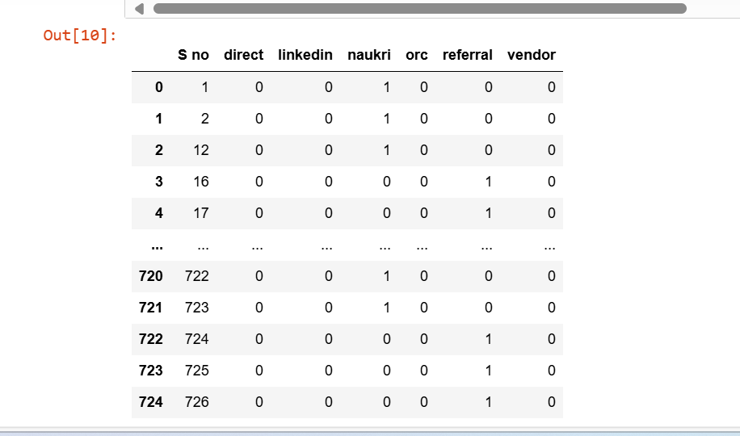
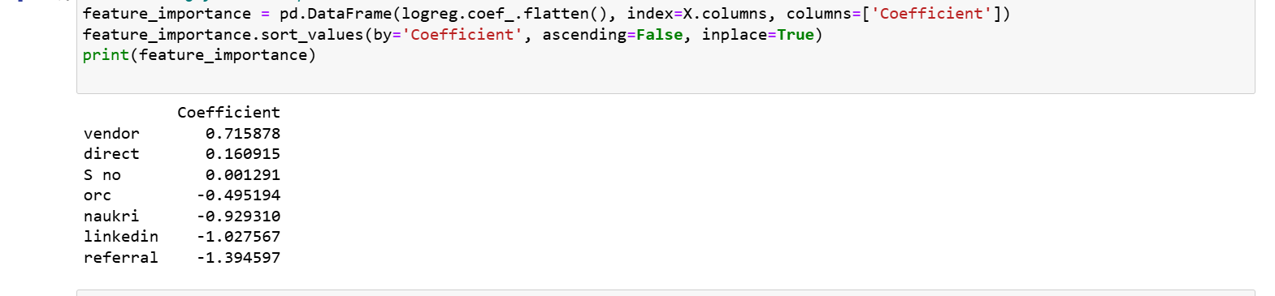
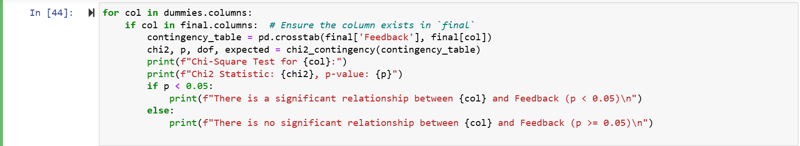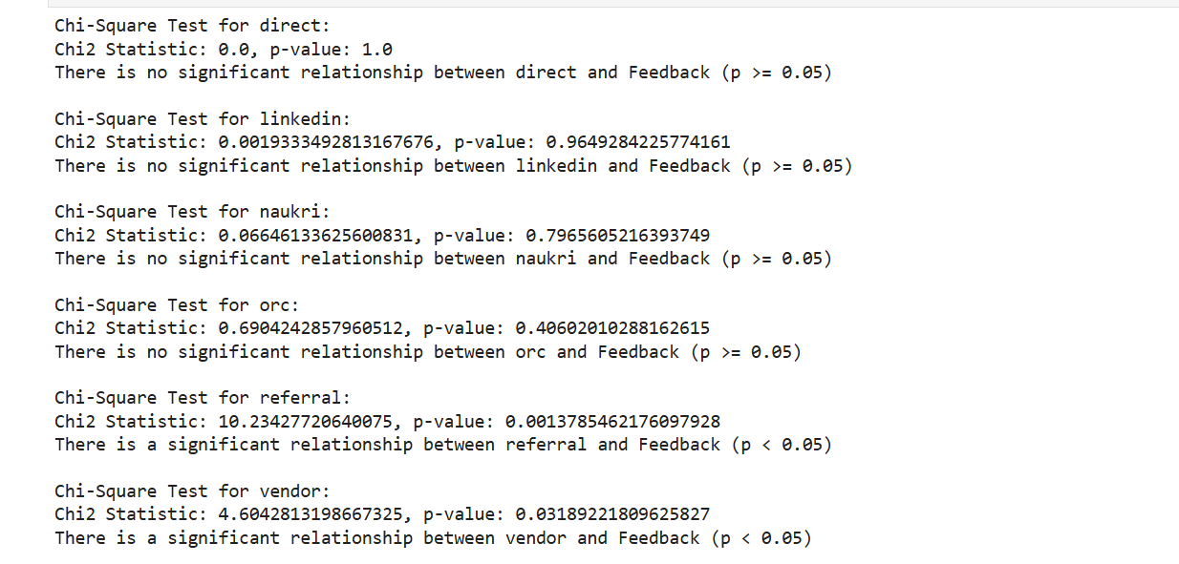

Findings
The chi-square test results yielded the following insights for each recruitment source:
- Direct: Chi-square statistic = 0.0, p-value = 1.0 — No significant relationship with selection outcomes, as p>0.05p > 0.05p>0.05.
- LinkedIn: Chi-square statistic = 0.0019, p-value = 0.9649 — No significant relationship, as p>0.05p > 0.05p>0.05.
- Naukri: Chi-square statistic = 0.0665, p-value = 0.7966 — No significant relationship, as p>0.05p > 0.05p>0.05.
- ORC: Chi-square statistic = 0.6904, p-value = 0.4060 — No significant relationship, as p>0.05p > 0.05p>0.05.
- Referral: Chi-square statistic = 10.2343, p-value = 0.0014 — Significant relationship with selection outcomes, as p<0.05p < 0.05p<0.05.
- Vendor: Chi-square statistic = 4.6043, p-value = 0.0319 — Significant relationship with selection outcomes, as p<0.05p < 0.05p<0.05.

Summery and Conclusion
The results indicate a significant relationship between recruitment source and selection outcomes for candidates sourced via referrals and vendors, as these sources yielded p<0.05p < 0.05p<0.05 values.
This suggests that candidates from referral and vendor channels may experience different selection success rates compared to other sources. In contrast, direct, LinkedIn, Naukri, and ORC sources showed no statistically significant relationship with selection outcomes, implying they do not independently impact the likelihood of selection.

Hypothesis Decision
From the calculated results, we reject the null hypothesis (H0) and accept the alternative hypothesis (H1). This supports the conclusion that different recruitment sources can indeed impact selection outcomes, with referrals and vendor sources exhibiting a distinct influence on candidate selection success. This results highlight the importance of optimizing recruitment channels to enhance selection effectiveness and support to select potential talent acquisition.
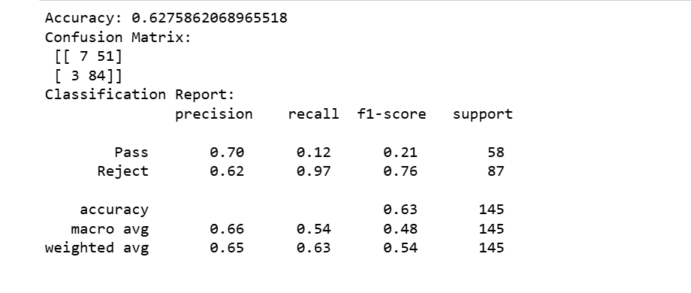
The model's accuracy for predicting selection outcomes was 62.76%, indicating moderate reliability. The confusion matrix ([7 true positives, 51 false negatives], [3 false positives, 84 true negatives]) suggests that while the model accurately predicted rejected candidates, it struggled with predicting passes. The classification report highlights this imbalance, with the "reject" class achieving a high recall (0.97), but the "pass" class showing low precision (0.70) and recall (0.12).
F1-Score Analysis:
Pass (F1 = 0.21): The F1-score for predicting "pass" is low, due to a combination of low precision and recall. The model struggles with effectively balancing the accuracy of positive predictions, likely resulting from an uneven distribution in the data or feature weightings that do not emphasize factors indicative of success.
Reject (F1 = 0.76): The "reject" F1-score is considerably higher, illustrating that the model performs well in balancing precision and recall for predicting non-selection. This demonstrates that, while the model can reliably forecast rejections, the imbalance suggests potential overfitting to the majority class, impacting its effectiveness in identifying positive outcomes.

Final Conclusion for the Thesis:
The overall analysis reveals that different recruitment sources have a varied impact on candidate selection outcomes. Notably, the Chi-square test findings emphasized significant relationships between certain recruitment channels and success rates (e.g., referral sources showed significant relationships with selection outcomes, p < 0.05). The logistic regression coefficients further supported that vendor recruitment channels had a positive influence, whereas platforms like LinkedIn and Naukri had negative coefficients, suggesting potential challenges in translating candidates from initial selection to final hiring success.
Despite the model’s 62.76% accuracy, the low recall for the "pass" category implies that more nuanced data handling, feature engineering, or perhaps ensemble methods could be explored to improve the identification of successful candidates. The F1-score disparity points to the need for a deeper examination of recruitment source weightings and candidate background attributes that influence success.
These insights align with existing research that emphasizes the critical impact of tailored recruitment strategies and the differential effectiveness of sourcing channels .Implementing data-driven hiring practices that leverage high-performing sources and address underperformance areas can ultimately enhance strategic talent acquisition outcomes and improve model predictions for candidate success across stages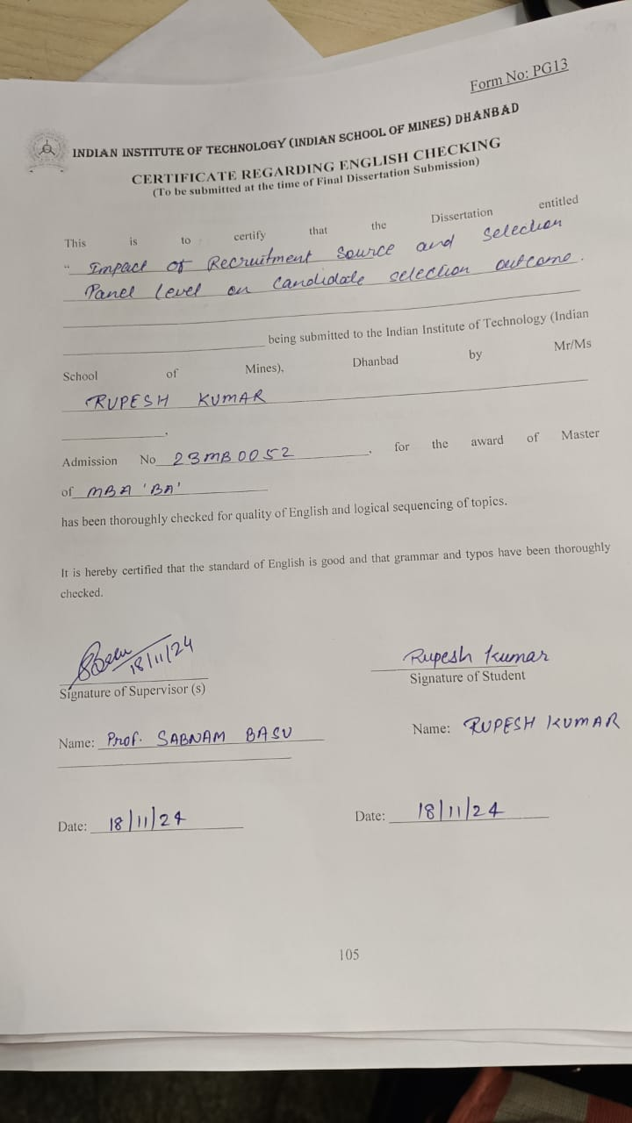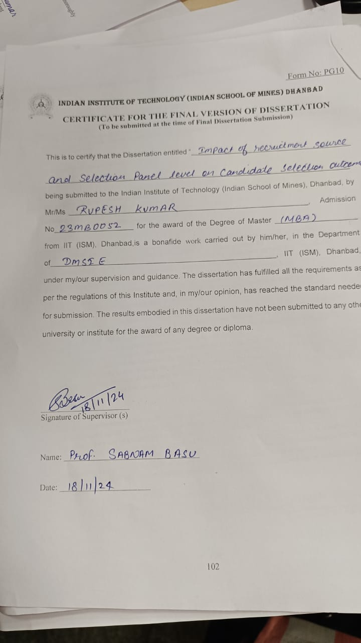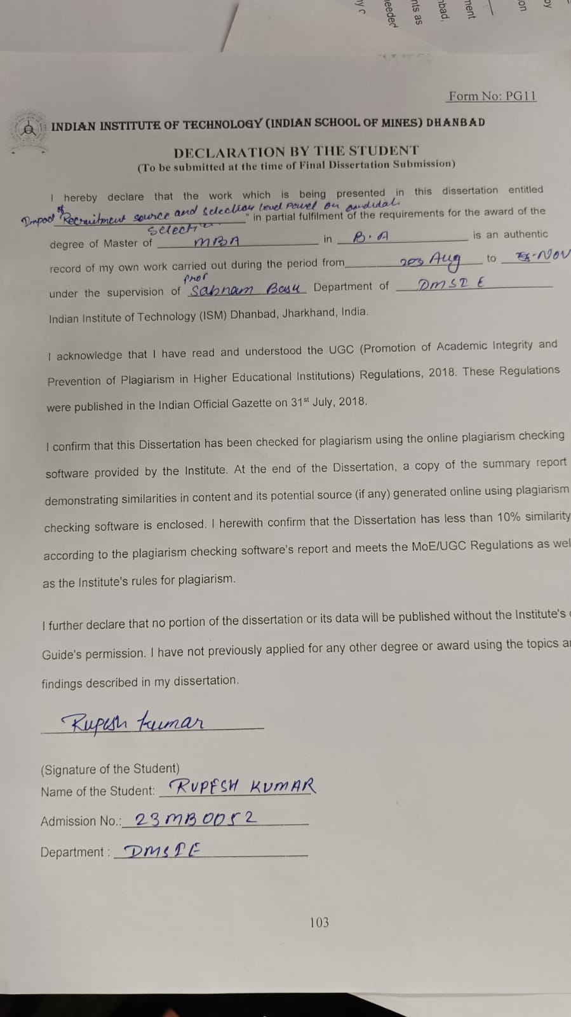

References
Allen, D. G., Mahto, R. V., & Otondo, R. F. (2004). The role of recruitment source and panel composition in strategic decision-making.

Cable, D. M., & Turban, D. B. (2001). Establishing the dimensions, sources, and value of jobseekers’ employer knowledge during recruitment.

Holtom, B. C., & colleagues (2021). Research on recruitment platforms and employee engagement.

Landau, J. (2021). Selection panel effectiveness and structured interview outcomes.

Suwarto, F. X., & Subyantoro, A. (2021). The effect of strategic human resource management, transformational leadership, and information sharing on organizational performance.

Torrington, D., Hall, L., Taylor, S., & Atkinson, C. (2011). Human resource management.

Werbel, J. D., & Landau, J. (1996). The effectiveness of different recruitment sources: A mediating variable analysis. Journal of Applied Social Psychology, 26(15), 1337-1350.

Williams, C. R., Labig, C. E., & Stone, T. H. (2003). Recruiting sources and post-hire outcomes for job applicants and new hires. Journal of Business and Psychology, 18(3), 405-421.

Williams, C. R., & Labig, C. E. (2000). Recruiting sources and post-hire outcomes for job applicants and new hires.

Weller, I., et al. (2013). Recruitment methods and their effects on job acceptance and performance.

Weller, I., Holtom, B. C., Matiaske, W., & Mellewigt, T. (2009). Level and time effects of recruitment sources on early voluntary turnover. Journal of Applied Psychology, 94(5), 1146.

Weller, I., Holtom, B. C., Matiaske, W., & Mellewigt, T. (2020). Level and time effects of recruitment sources on early voluntary turnover. Journal of Applied Psychology.

Zottoli, M. A., & Wanous, J. P. (2000). Recruitment source research: Current status and future directions. https://doi.org/10.1016/S1053-4822(00)00032-2.

